Setting up SFTP server in Ubuntu server VM and sharing files with windows host PC

SSH into your VM first

Run update and upgrade for the system packages



Install openssh-server



Verify SSH service is running if not can use sudo systemctl start ssh and then sudo systemctl enable ssh to keep it running on next reboot

Now create a group dedicated for sftp users access and add a new user to the group and set the new user to nologin so they won’t be able to access via ssh. They can transfer files via SFTP but not able to access the server itself



Set password for the SFTP user account

Create a directory for your sftp uploads



As currently home/sftpubuserver is still on your username and group we need to change the base directory **/home/sftpubuserver** to root:root first to ensure it is not writable by any other user and group

Sets secure permission

Let’s recall the sftp user and the user group we created



We then set permission for subdirectory of our share folder to be writable by our user and group

*Side note*: sometimes I forget chown syntax so tldr came in handy. In this case we have to chown sftpubuserver:sftp_users for /home/sftpubuserver/sftpshare

After applying the necessary folder ownership:

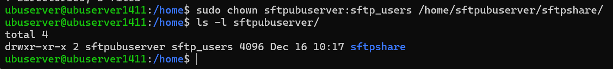

However, as we want to let users in sftp_users to write to this folder as well, we will need to set 775. Execute only allows users to access the files but writing can let them create/delete/edit.

Edit the SSH config file



Add this to the end of the file

Explanation:

* Match Group sftp_users: Applies these rules to anyone in the sftp_users group
* ChrootDirectory /home/%u:
* %u automatically gets replaced with the logging-in user's username so if user "john" logs in, they're chrooted to /home/john
* ForceCommand internal-sftp: Forces SFTP only, no SSH shell access
* AllowTCPForwarding no: Prevents port forwarding
* X11Forwarding no: Prevents X11 GUI forwarding

Restart SSH service for changes of config file to take effect

Now if we open cmd from our host windows pc and sftp in using the sftp user account we created we can see that it is connected.

You can cd into the share folder which users in the sftp_users group have rwx acccess

Now for example we have a file in our C drive

We can try to put the file into the sftp folder (since we are already in the sftpshare sub folder we can do this straight)



However if you are in root directory and wants to upload the testfile.txt from your local host pc to the sftpshare subfolder



As you can see we can now also view the file from our ubuntu server VM



HARDENING – to improve security of our SFTP server

We can disable root login over SSH. As seen in our sshd_config, we can change the PermitRootLogin to implicit no.

First make a copy in case of rollback



Then edit the file



Then restart SSH service to apply the changes

